ANSIBLE INSTALLATION:

# yum install ansible

# amazon-linux-extras install ansible2 # ansible --version

# cd /etc/ansible # ls

Connecting one server to another server: create user in two server

MASTER:

# useradd ansadmin # passwd ansadmin # visudo

Add this below line without password section ansadmin ALL=(ALL) NOPASSWD: ALL

# vi /etc/ssh/sshd_config

change the below line from no to yes passwordauthonit yes

# service sshd restart NODE:

# useradd ansadmin # passwd ansadmin # visudo

Add this below line without password section ansadmin ALL=(ALL) NOPASSWD: ALL

# vi /etc/ssh/sshd_config

change the below line from no to yes passwordauthonit yes

# service sshd restart

GENERATING SSH KEYS In master server: # su ansadmin

# ssh-keygen

enter-enter-enter

# cd /home/ansadmin/.ssh (keys installed location)

# ssh-copy-id ansadmin@private ip node (copying keys) password of username

# ssh ansadmin@private ip node # hostname -i

# exit

TO configure ping connection:

# cd /etc/ansible # sudo vi hosts

[all] username@private ip

# ansible -m ping all (connection successful )

AD-HOC COMMANDS:

# ansible all -m file -a "path=/home/ansadmin/hello.txt state=touch"

# ansible all -m file -a "path=/tmp/hello.txt state=touch mode='0777'"

-remove file:

# ansible all -m file -a "path=/home/ansadmin /hello.txt state=absent"

-directory:

# ansible all -m file -a "path=/home/ansadmin /hello.txt state=directory"

-copy:

# ansible all -m copy -a "src=/etc/ansible/filename dest=/home/ansadmin"

- install;

# ansible all -m yum -a "name=httpd state=started" Creating user:

# ansible all-m user -a "name=james password=redhat"

To confirm the creation of the new user, run the command:

# ansible all-a "id james"

To remove the user, run the command:

# ansible all-m user -a "name=james state=absent"

PLAYBOOKS:

###file copy to localhost

---

* hosts: localhost tasks:
  + copy: src=/home/user/demo.txt dest=/tmp
  + command: mkdir /tmp/yaml_files

## HTTPD SERVER

# sudo vi httpd.yml

---

* name: insatlling httpd package hosts: localhost

tasks:

* + name: insatll httpd yum:

name: httpd state: present

* + name: start httpd service:

name: httpd state: started

* + name: copy sample template file template:

src: index.html

dest: /var/www/html

COMMANDS TO INSTALL ANSIBLE to AWS :

# amazon-linux-extras install ansible2 -y # ansible --version

# python --version

# yum install python2-pip -y

# pip install boto (boto connect playbook to aws) # pip show boto

# # aws configure

Access Key ID:

Secret Access Key:

Region:

# @@ Creating Ec2 instance using ansible playbook

# cd /etc/ansible # vi ec2.yml

---

* hosts: localhost gather_facts: True tasks:
  + name: creating Ec2 instance from ansible playbook ec2:

key_name: Ireland-Sasi region: eu-west-1 instance_type: t2.micro

image: ami-0d71ea30463e0ff8d wait: yes

group: default count: 1

vpc_subnet_id: subnet-020bebeb8c4a22059 assign_public_ip: yes

# #### Create Role in Ansible

# cd /etc/ansible

# sudo ansible-galaxy init lamp ((create role)) # ls

# sudo yum install tree -y # tree lamp

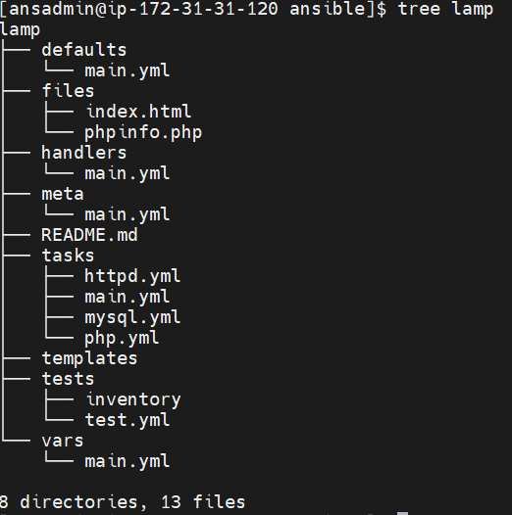

# cd lamp/tasks

# sudo vi httpd.yml

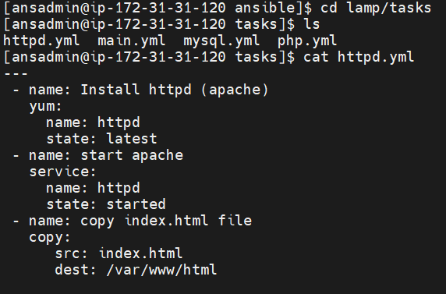

# sudo vi php.yml

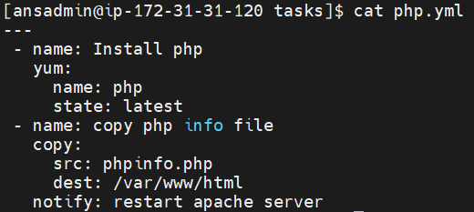

# sudo vi mysql.yml

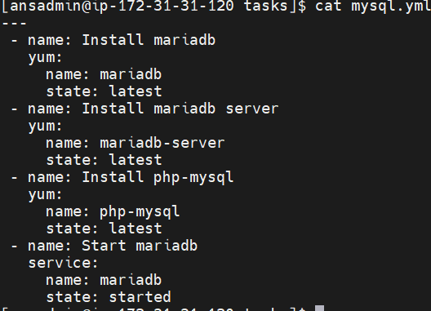

# sudo vi main.yml

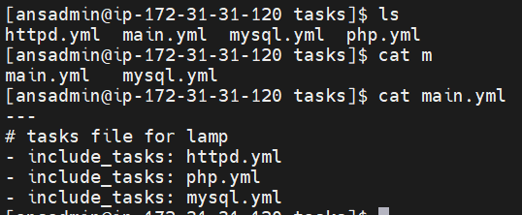

# cd ..

# cd files

# sudo vi index.html (( insert data))

# sudo vi phpinfo.php (dataaaa)

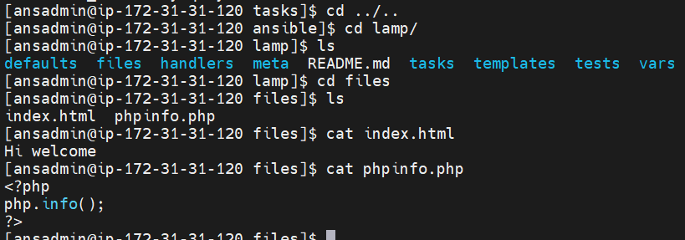

# cd ..

# cd handlers

# sudo vi main.yml

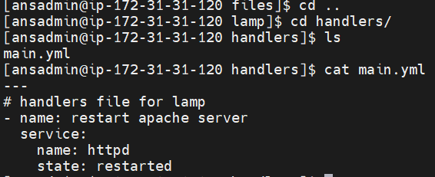

# cd ../..

# sudo vi mylamp.yml

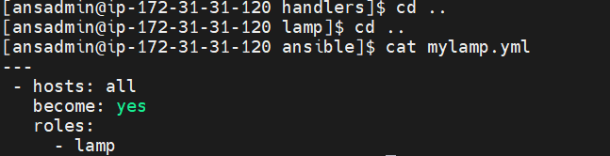

# ansible-playbook mylamp.yml –syntax-check # ansible-playbook mylamp.yml

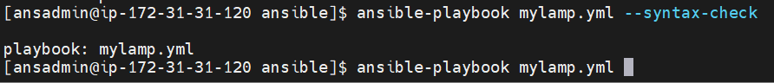

LOGIN TO NODE SERVER:

